# **Marriage Compatibility - Astro Exceptions > Astro Rules**

*Dr. Balaji Ramanathan*

*******Dr. R. Balaji is a professional practising astrologer. He is working in a Central Govt. Organisation at Hyderabad. He has completed his Master’s Degree in Astrology in first class from Potti Sree Ramulu Telugu University. He has done research work in Progeny – KP System under their guidance of Dr. NVRA. Raja and Dr. Vijayalakshmi and awarded Ph.D. (Vedanga Jyothisha) from Yoga Samskrutam University, Florida, USA. He was awarded with Jyothisa Praveena in KP System under the guidance of Guruji. Late PVK. Punneswara Rao, founder of M/S. Universal college of Astrology, Hyderabad. Also undergone Nadi Astrology courses under the guidance Prof. A. V. Sundaram at ICAS, Hyderabad chapter and also from Prof.Satyanarayana Naik.*

My Guruji, Late Shri. PVK Punneswara Rao used to stress on an important point that all of us, students should be thorough in astrological rules, its exceptions and cancellations. He used to say that more than the rules; exceptions to the rules play an important role in determining the results of a particular chart. He opines most of the practising astrologers make inaccurate predictions by just applying basic/rudimentary rules without considering exceptions to the rules which alters the results. We have seen, in so many cases that afflictions/doshas in a chart get nullified/cancelled when we consider the exceptions to the rules. This can be very well seen in Kuja dosha, where the exceptions/cancellations are more in number than the number of rules in itself. In many of the horoscopes where Kuja dosha is seen with respect to Asc/Moon/Venus gets nullified while applying exceptions to the original tenets. Even Punarpoo dosha caused by Saturn & Moon connection gets cancelled by the connection of Sun with Saturn. But in practice most of the practising astrologers miss this point of cancellation and make inaccurate predictions.

This inaccuracy or wrong evaluation of a chart is commonly seen in marriage compatibility, where most of the astrologers restrict themselves in matching charts to the extent of looking into important Kutas/Poruthams namely (Rasi, Rasiadipathi, Vasiyam, Mahendra, Gana, Yoni, Dina, Stree Deergha, Rajju, Vedha, Nadi), Kuja Dosham, Dasa Sandhi, Papasamyam. But they seldom analyse in depth without considering exception rules in Kutas & in Kuja dosham, this apart, planet to planet synastry between the girl & boy chart is not being seen. Hence invariably, we might have come across two different versions being given by either of the sides (girl & boy) of the astrologers. Particularly in a marriage match-making, girl’s side and boy’s side astrologers do not give the same opinion. This is purely because of not making an effort to analyse in depth without considering the exceptions to the rules. Because of this, I would like to enumerate the exceptions in the Kuta matching.

The following are the nullifying factors, if present, can ignore certain incompatibilities in the Kuta matching: -

* The absence of Stree- Deergha may be ignored if Rasi Kuta and Graha Maitri are present.
* Though Graha Maitri is the most important, it need not be considered if the couple has their Janma Rasis disposed in one and seven from each other.
* Rajju kuta need not be considered in case Graha Maitri, Rasi, Dina and Mahendra Kutas are present.
* The evil due to Nadi kuta can be ignored
* If Rasi and Rajju Kuta present,
* If the same planet is lord of the Janma Rasis of both the boy and girl,
* If the lords of the Janma Rasis of the are friends
* In case of common Janma rasis, according to sage Narada, common Janma rasis would be conducive to the couple provided they are born in different constellations. Garga opines the asterism of the boy should precede that of the girl for a happy married life. In case of the reverse i.e., the constellation of the girl precedes that of the boy, that one should be rejected.
* In case the Janma Nakshatra of the girl and boy is same, the following nakshatras are approved- Rohini, Arudra, Magha, Hasta, Vishaka, Sravana, Uttarabhadra, and Revati.
* The effect is neutral in case of Aswini, Kritika, Mrigasira, Punarvasu, Pushya, Pubba, Uttara, Chitta, Anuradha, Poorvashada, and Uttarashada.
* In case of Swati, Jyesta, Moola, Dhanista, Satabisha and Poorvabhadra, it is not recommended. However, in case of Swati, opinions are divided.
* In case the Janma Nakshtra belongs to two signs (suppose Kritika), the pada of the girl should be the preceding sign. For example, if Kritika is the common Janma Nakshatra between the boy and girl, the girl should have her Janma Rashi in Mesha and the boy is Rishaba.
* The couple should not have the same Janma Rasi, same Janma Nakshatra and pada. However, with respect to Satabisha, Hasta, Swati, Aswini, Kritika, Poorvashada, Mrigasira, and Magha, the evil given rise to, by virtue of common Janma Rasi, Nakshatra, and Pada gets cancelled if the couple are born in the first pada.
* Kuja dosha is caused by placement of Mars in 2nd, 4th, 7th, 8th, and 12 reckoned from Ascendant, Moon and Venus in a both girl & boy horoscope. More importance is given to the presence of Kuja dosha in female horoscope. However, this dosha/affliction gets nullified/cancelled if Mars are placed in the signs mentioned below corresponding to different houses.

2nd house – Mithuna & Kanya

4th house – Mesha & Vrichika

7th house - Karakataka & Makara

8th house - Dhanus & Meena

12th house – Rishaba & Thula

Placement of Mars in Simha & Kumbha causes no affliction/dosha whatsoever irrespective of analysing with respect to Ascendant/Moon/Venus.

The dosha gets counteracted by the conjunction of Mars & Jupiter, Mars & Moon, and also presence of Jupiter & Venus in ascendant.

* When it comes to planet-to-planet matching/synastry between the girl & boy horoscopes by superimposing each other charts, priority is given to Saturn, Jupiter, and Nodes, but least importance is given to other planets. Gone are the days where the age difference between the boy & girl remained 5 to 7 years. In those cases, you invariably find perfect synastry of Jupiter, Saturn & nodes not occupying the same Rasis or 2/12 placements. In fact, the mere age difference of 5 to 7 years itself takes care of the mutual compatibility, wherein the placements of slow-moving planets occupy themselves in perfect synastry. But in recent times girls are not interested in marrying a boy who is older than them by 2 or 3 years. Hence, we come across in matching, where the placement of Saturn is occupying the same Rasis, Jupiter either in the same Rasis or in 2/12, in both these cases results in imperfect synastry, which is the reason for the cause separation and divorce. However, it is difficult for an astrologer to change this present trend, but in spite of this inadequacy, we can recommend mutual compatibility provided if Saturn is connected to Venus either by conjunction, aspects or Stellar level in each other’s charts or Jupiter’s connection to Mars/Moon in each other’s charts.

Hence, I conclude that while matching horoscopes for mutual compatibility utmost care should be taken and the charts should be analysed in depth in a holistic manner.

# **Rain fall Prediction Through Kartevahana Method of Vedic Astrology**

*ML. Arvinda Swamy*

Ancient scholars of India studied the 5 elements of nature Agni (Fire), Bhoomi (Earth), Vayu (Air), Jalamu (Water) and Akshamu (Sky) much before the now so-called modern science of Astrometeorology. Continuous observations of Celestial bodies and its effect on human’s life on earth were observed Through ages. they devised the rules based on the movement of luminaries like sun and moon and the planets Venus, Mars, Jupiter, Saturn and Chaya Grahas Rahu and Ketu which are the nodes of the Moon in Nakshatra Rashis or Zodiac signs.

For the benefit of mankind their observations and finding are given in the form of slokas in scriptures. All the events which are occurring on the earth are due to effect of celestial bodies. Based on the movement and positions in particular nakshatra rashis they devised the method of predicting the rains well in advance without the need of sophisticated instrument like satellites and Radars in those days.

Food is the main source of all the activities of living creatures in the world without food nothing can survive and sustain. Different types of foods and food products are generated by Agriculture and it is the main source of lively hood for more than 70 % population in India. Farming and agricultural practices done by farmers are solely dependent on rains and it will directly and indirectly effect the wellbeing of the society and economy of the country.

Farmers start farming from the onset of Rainy season / Monsoon in India. Rainfall dynamics will completely change the entire Agricultural practices like ploughing the soil, sowing the seeds, harvest and storing the crops will be dependent on timing of rain, nature of rain and quantity of rains.

Fertile lands, Quality seeds, man power, and good agricultural practices all are useless if we don’t have rains. If rainfall and quantity of rain is predicted in advance we can decide when to plough the soil, sowing seeds and nature of crops to be cultivated based on rainfall. Prediction of rainfall in advance has many advantages for farmers based on these they can decide which crops to be cultivated, Land area of cultivation, ideal time to start agricultural practices and precautions for harvesting and storing the crops. Rainfall prediction will not only improve the production and quality of crops but also minimize the agricultural expenses and debts of the farmers.

**India's climate is affected by Monsoon/Seasonal winds:**

South-west monsoon which blows from Arabian Sea and Bay of Bengal Sea to land after crossing the Indian Ocean bringing most of the rain in the country during June to September known as summer monsoon. Northeast monsoon (Post Monsoon) is from October to December in Southern Peninsula and is commonly known as Winter Monsoon which blows from land to Sea.

**Rain fall Prediction methods:**

Rainfall and prosperity of crops can be studied by predicting Monsoon/ Rainfall. Several prediction methods are given by great saints by Varahamihira, Parashara, Gargamuni and others in several texts for the welfare of the society. There are several methods in predicting the rains in a particular area depending upon the geographical conditions of the place. 1.Kartevahana method based on the sun and moon Transitions 2. Sapthadnadi, 3. Arudra Pravesham, 4. Nakshatra Prasna, and Jagadlagnam. Based on the type of method used rainfall can be predict/forecast rains ranging from 1 day to 2 days (Short range) weeks (Medium range) and whole rainy season (Long range). Rainfall and type of crops suitable are also predicted based upon the 60 Year Telugu calendar names, based on the position of Jupiter also rainfall predictions were done. Few methods based on observation of 1 to 3 days in Aashad month (Ashadi Yoga) When Moon transit into Swathi (Swathi Yoga), Rohini (Rohini yoga) and Mrugashira nakshatras can predict the rain fall for that whole year and the types of crops can be grown or crops which can survive during that period are also used for prediction.

Farmers will start the agricultural work depending upon the monsoon. Paddy crops and few other crops need more water and cultivators will look for monsoon rainfall. Rainy season in India start with the onset of South-West monsoon, generally begin in late May or early June month and ends in the month of September. Rainfall season starts with the sun entry into Gemini sign (Airy Sign) in Mrugasira Nakshatra and further movement of Sun in watery sign cancer will improve the rainfall. In India Rainy season will be for a period of 4 months from June to October. South west monsoon provides more rains in different regions of India whereas North -East monsoons also give rains but the amount of rainfall will be very low when compared to the North -East monsoon rainfall.

**Kartevahana method for predicting rainfall:**

Kartevahana rainfall prediction method is widely used in many parts of the country and it is very popular among farmers especially in southern states of India. Karte will give the status of the amount of rainfall for 14 days. method will not precisely tell on which day rain will be there but it will indicate the total amount of rain fall for that place based on which farmers will decide the farming practices like plough the soil, planting crops, harvesting crops and storing.

Kartevahana method involves tracking sun movement/ entry time in different nakshatras (each sign is about 30 degrees and Sun moves 1 degree per day and completes 30 days for each sign and covers entire zodiac of 360 degrees in 12 months). In every sign there will be 9 Nakshatra padas and 4 padas make one nakshatra spanning about 13.20 degrees per nakshatra. In each sign there will be 3 Nakshatras either in combination of 2 complete nakshatras and 1 incomplete nakshatra spreading to another sign. Entry of sun in particular Nakshatra and Moon Nakshatras at that time will give particular karte vahana. Each kartevahana has some value based on that value rainfall can be forecasted well in advance.

There are 2 methods for predicting rainfall based on the karte/ sun entry into particular nakshatra

**Method:1**

Kartevahana is the means of finding the amount of rainfall prediction at particular location for a period of 2 weeks in advance. This method involves tracking of Sun entry time into particular nakshatra and counting 27 nakshatras from sun entry time in a particular nakshatra in the zodiac sign to the moon nakshatra and the value obtained will be divided by 9 will give the kartevahana and each kartevahana represent certain amount of rainfall.

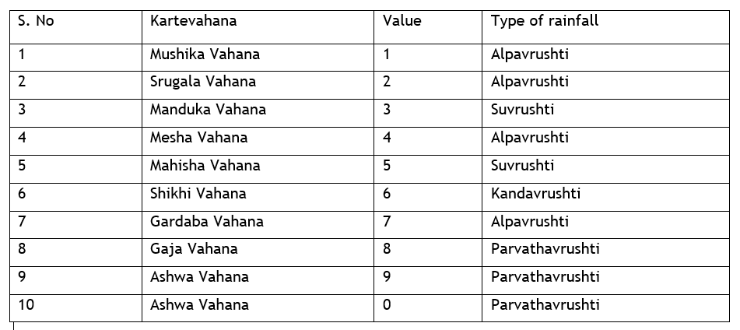

**Method:2** Karte prediction based on Nakshatra lingam (Gender)

This method based on the Genders of Sun and Moon Nakshatras at the time of sun entry into particular karte will also predict the rainfall for particular location. The given below table shows the genders of the nakshatras.

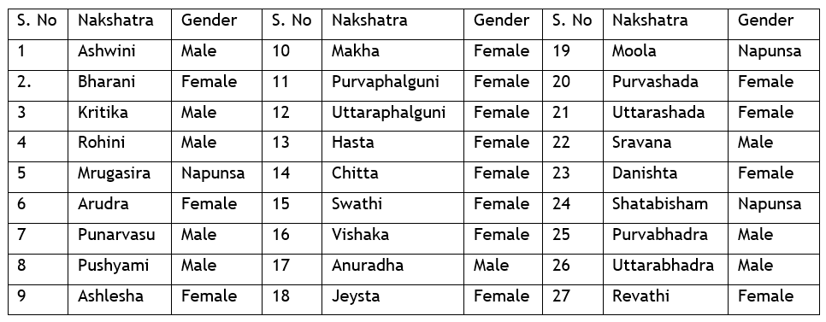

Based on knowing the genders of the sun and moon nakshatras on a particular day also we can predict the climatic conditions on that day and taken into consideration of the particular location climatology. Given below table provided climatic conditions and rainfall based on the season and geographic climatic conditions.

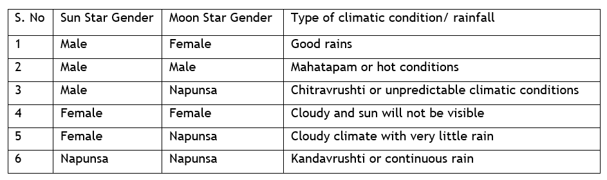

The day of Sun entry in these signs is to be noted from one sun rise to the next day sun rise. If the day happens to be Monday, Thursday and Friday, very good rainfall and crop production can be expected.

If the day happens to be on Wednesday, undue winds would occur and scatter the clouds. As a result, less rains would be experienced and prices rise due to scarcity of food grains.  If the day happens to be on Sunday, Tuesday and Saturday, medium rainfall would occur and scarcity of food grains would happen as a result. We have to check this for all the above 4 signs and arrive at the prediction connected with each of them.

Based on Kartevahana method rainfall prediction for the Telugu year plavanama samvatsara (2021- 2022) was done.

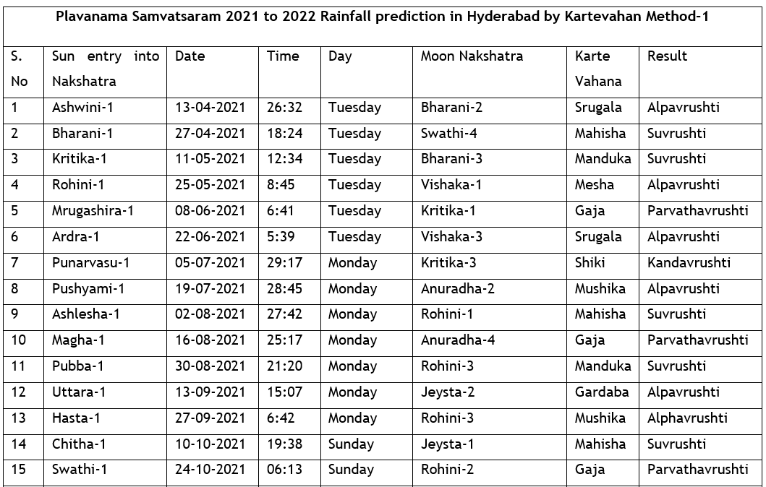

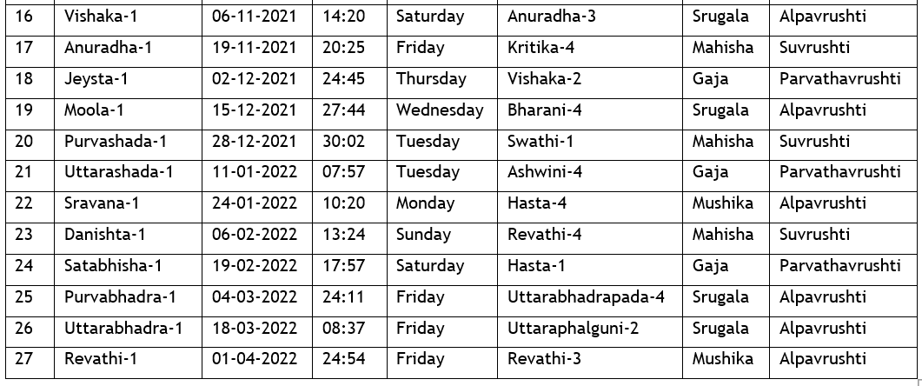

* Ashwinin Karte 13-04-2021 to 26-04-2021: Lagna at that time fall under the Capricorn which is earth sign and Moon in Purvabhadra Nakshatra indicates humidity and strong winds and hot climate due to the aspects of Mars on lagna very scanty or little rain in few parts of the Hyderabad.
* Bharani karte 27-04-2021 to 10-05-2021:

Libra Lagna is Airy sign and its house lord is Venus posited in Aries sign. Moon in Swathi Nakshatra. Lagna is aspected by both Jupiter and Saturn indicate good rains in the direction of South East direction and North East direction of Hyderabad and climate will be little cold in the evenings and with normal and pleasant climate in Hyderabad.

* Kritika Karte 11-05-2021 to 24-05-2021: Lagna is Leo (Fiery sign) and lagna lord sun is in 9th house along with moon in Fiery sign, Jupiter is aspecting lagna from airy sign indicates very hot winds in the day time and rains in North- East and East directions of Hyderabad.
* Rohini Karte 25-05-2021 to 07-06-2021: Lagna is Gemini which is airy sign and planet Mars is posited indicate very hot winds in North East directions of Hyderabad and in the evenings, climate will be little cold and with very scanty rains in few locations.
* Mrugashira Karte 08-06-2021 to 21-06-2021: Lagna is Gemini, Airy sign and Venus is posited in lagna aspected by Jupiter from Airy sign and presence of moon in Kritika star and Mars aspecting Jupiter from watery sign indicates good rains at North east direction of Hyderabad and in remaining places climate will be hot.
* Ardra Karte 22-06-2021 to 04-07-2021: Lagna is Gemini and lagna lord Mercury is earthy sign Jupiter is aspecting lagna and Mars is aspecting Jupiter and Saturn is aspecting Mars posited in watery sign indicates windy climate and little rains with thunders can be expected in North east direction of Hyderabad.
* Punarvasu Karte 05-07-2021 to 18-07-2021: Lagna is Gemini and presence of watery planet Venus in watery sign along with Mars. Jupiter aspects Lagna indicates good rains in the direction of East and south east direction of Hyderabad.
* Pushyami karte 19-07-2021 to 01-08-2021: Lagna is Gemini airy Sign and presence of Airy planet Mercury Lagna indicates less rains and the climate will be windy and pleasant with cool winds in the evenings.
* Aslesha Karte 02-08-2021 to 15-08-2021: Lagna is Gemini airy Sign and presence of planet Mercury and Sun in watery sign indicate depression/ cyclone like conditions in eastern side of Hyderabad, Bay of Bengal which is aspected by Saturn indicates good rains with thunders in North east directions of Hyderabad.
* Magha Karte 16-08-2021 to 29-08-2021: Lagna is Taurus and good rains are expected in South and south East directions of Hyderabad.
* Purvaphalguni Karte 30-08-22 to 12-09-2021: Lagna is Fiery sign and rains are expected in south west direction of Hyderabad.
* Uttara phalguni Karte 13-09-2021 to 26-09-20212: Lagna is Capricorn and no positive planets for rains indicates very low rains or no rains during this period.
* Hasta Karte 27-09-2021 to 09-10-2021: Lagna is Capricorn Jupiter and Saturn both are in lagna there will be no rains or little rains and the climate will be cool in south -west and western regions of Hyderabad.
* Chitta Karte 10-10-2021 to 23-10-2021: Lagna is Pisces watery sign and presence of 3 planets Jupiter, Moon and Saturn indicate cool climate in western and North west regions of Hyderabad and rains are expected in these regions.
* Swathi Karte 24-10-2021 to 05-11-2021: Lagna is Scorpio and presence of Mercury, Ketu, Sun indicates depression in the sea in Indian ocean towards Arabian sea due to these very good rains are expected in South and South east direction of Hyderabad and north and north east directions of the Hyderabad.
* Vishaka Karte 06-11-2021 to 18-11-2021: Lagna is watery Sign Aquarius and no positive effects for rain but the climate will be cooler due to presence of cold and watery planes are very nearer to earthy signs.
* Anuradha Karte 19-11-2021 to 1-12-2021: Lagna is Airy Sign Gemini aspected by Venus indicates rains in few regions of North east direction.
* Jeysta Karte 02-12-2021 to 14-12-2021: Lagna is Leo and presence of Sun and Mercury in watery sign in Scorpio indicates low pressure area in the Arabian Sea indicates good rains in the direction of East and South East Directions of Hyderabad.
* Moola Karte 15-12-2021 to 27-12-2021: Lagna is Airy sign Libra and Moon is aspecting from Aries and presence of Sun and Mercury in the Sagittarius Sign indicates low pressure areas in Arabian sea. Jupiter aspects lagna and there will be no rains are scanty rains in the south direction of Hyderabad and cold winds will be there during this period.
* Purvashada Karte 28-12-2021 to 10-01-2022: Lagna is Sagittarius and presence of Mecury, Sun and Moon indicates low pressure in the sea in Arabian sea. There will be rains in the South west directions of Hyderabad.
* Uttarashada Karte11-01-2022 to 23-01-2022: Lagna is Capricorn earthy sign and presence of Saturn and Mercury indicate cold winds are more prevalent in the West and North west directions of Hyderabad and good rains can be expected during this period
* Sravana Karte 24-01-2022 to 05-01-2022: Lagna is Capricorn earthy sign and presence of Saturn and Mercury and Sun indicate very col d climate and cold winds are more prevalent in the West and North west directions of Hyderabad and there will be no rains and few regions scanty rains can be expected.
* Danishta Karte 06-02-2022 to 18-02-20212: Lagna is earthy sign Taurus and there will be less rains in few regions.
* Shatabisha Karte19-02-2022 to 03-03-2022: Lagna is Airy Sign Gemini aspected by Saturn and Mars from Fiery sign, Jupiter and Sun in Aquarius windy sign indicates hot climate and warmer winds during this period and rains are expected with thunders in North east direction and South directions of Hyderabad.
* Purvabhadra Karte 04-03-22 to 17-03-2022: Lagna is Watery sign Scorpio and planet ketu is posited in lagna and there are no positive aspects very low rains occur during these periods in few regions of Hyderabad.
* Uttarabhadra Karte 18-03-2022 to 31-03-2022: Lagna is Aries Fiery Sign and there are no positive combinations for rains during this period few regions very little rains are expected.
* Revathi Karte 01-04-2022 to 14-04-2022: Lagna is fiery sign Sagittarius and there are no positive combinations for rains during this period.

According to the Telugu year Plava nama Samvatsaram rainfall will be average and different types of millets crops will be cultivated in large area.

*Note: With Guru ji Blessings these observations and calculations are made according to the astrology texts and literature. Any deviation in the results is only due to my observations and analysis but not due to the Astrology literature. I am trying my best to understand the subject and try to create awareness for ancient Astro science in predicting the Rainfall. I hope you will encourage me to improve the deeper understanding of Astrology knowledge and Science beyond our limitations. I hope you will accept this article and forgive me for mistakes*.

ML. Arvinda Swamy

Ph. D 2019-2021

9246296946